The dataflow diagram shows how data will flow in the existing system.

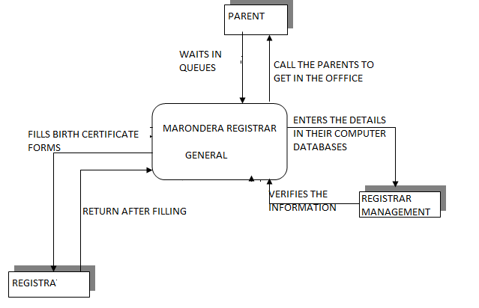

**Figure 4.1 Context diagram of the proposed system**

